Voting App: final_voting_cicd
Step: 1 Create a Security Group
security group name: githubaction_sg
Inbound Security Group Rules
The following six inbound rules are configured in AWS.
No. | Type | Protocol | Port Range | Source / CIDR | Purpose
1 | SMTPS | TCP | 465 | 0.0.0.0/0 | Secure SMTP traffic
2 | Custom TCP | TCP | 3000–11000 | MyIP | Access to development and monitoring services
3 | HTTP | TCP | 80 | 0.0.0.0/0 | Public HTTP access
4 | HTTPS | TCP | 443 | 0.0.0.0/0 | Public HTTPS access
5 | SSH | TCP | 22 | My IP | Secure SSH access to EC2
6 | Custom TCP | TCP | 587 | MyIP | SMTP submission traffic
Step 2: Create Two Ec2 insatnces
Operating system: Ubuntu 24.04
AWS Region: eu-north-1
Configuration | voting-runner | voting-server
Instance type | m7i-flex.large | t3.small
Operating system | Ubuntu 24.04 | Ubuntu 24.04
Storage | 50 GiB gp3 | 30 GiB gp3
Key pair | voting_key.pem | voting_key.pem
Security group | githubaction_sg | githubaction_sg
Purpose | GitHub Actions, Docker, SonarQube, Trivy | Terraform, AWS CLI, kubectl, Helm
Step 3: Installation Part in Runner
Connect to voting-runner open gitbash terminal
ssh -i ~/Downloads/voting_key.pem ubuntu@<RUNNER_PUBLIC_IP>
sudo hostnamectl set-hostname voting-runner
exec bash
Update and install prerequisites:
sudo apt update
sudo apt upgrade -y
sudo apt install -y \
git curl wget unzip jq gnupg \
ca-certificates python3 python3-pip python3-venv
git --version
python3 --version
If your runner uses Python 3.12, install the version-specific package as well:
sudo apt install -y python3.12-venv
Verify:
python3 --version
python3 -m venv /tmp/voting-venv-test
Activate:
source /tmp/voting-venv-test/bin/activate
Check:
python -m pip --version
Then deactivate and clean up:
deactivate

rm -rf /tmp/voting-venv-test

Install Docker on Runner EC2
sudo install -m 0755 -d /etc/apt/keyrings

sudo curl -fsSL https://download.docker.com/linux/ubuntu/gpg \
-o /etc/apt/keyrings/docker.asc

sudo chmod a+r /etc/apt/keyrings/docker.asc
Add the Docker repository:
echo "deb [arch=$(dpkg --print-architecture) signed-by=/etc/apt/keyrings/docker.asc] https://download.docker.com/linux/ubuntu $(. /etc/os-release && echo "${UBUNTU_CODENAME:-$VERSION_CODENAME}") stable" \
| sudo tee /etc/apt/sources.list.d/docker.list > /dev/null
Install Docker:
sudo apt update
sudo apt install -y \
docker-ce \
docker-ce-cli \
containerd.io \
docker-buildx-plugin \
docker-compose-plugin

sudo systemctl enable --now docker
sudo usermod -aG docker "$USER"
Log out and reconnect to activate Docker group membership:
exit
exit
Reconnect from Windows Git Bash:
ssh -i ~/Downloads/voting-key.pem ubuntu@<RUNNER_PUBLIC_IP>
Verify:
docker --version
docker compose version
docker ps
docker run --rm hello-world
Configure SonarQube requirements
WHERE: RUNNER EC2
echo "vm.max_map_count=524288" | sudo tee /etc/sysctl.d/99-sonarqube.conf

echo "fs.file-max=131072" | sudo tee -a /etc/sysctl.d/99-sonarqube.conf

sudo sysctl --system
Verify:
sysctl vm.max_map_count
sysctl fs.file-max
Install SonarQube on the same Runner EC2
In RUNNER EC2 gitbash terminal
Create persistent Docker volumes:
docker volume create sonarqube_data
docker volume create sonarqube_extensions
docker volume create sonarqube_logs
Start SonarQube:
docker run -d \
--name sonarqube \
--restart unless-stopped \
-p 9000:9000 \
-v sonarqube_data:/opt/sonarqube/data \
-v sonarqube_extensions:/opt/sonarqube/extensions \
-v sonarqube_logs:/opt/sonarqube/logs \
sonarqube:lts-community
Check the container:
docker ps
Wait for SonarQube to initialize, then test:
curl http://localhost:9000/api/system/status
Expected response contains:
{"status":"UP"}
Open SonarQube in your Windows browser:
http://<RUNNER_PUBLIC_IP>:9000
Complete the initial login with username: admin password: admin and password-change to admin123 process.
Clone the updated Voting App repository
git clone https://github.com/harathi-mutyam/final_voting_cicd.git
cd final_voting_cicd

Install Python for vote
cd ~/final_voting_cicd
python3 -m venv .venv-vote

source .venv-vote/bin/activate

python -m pip install -r vote/requirements.txt

python -m compileall -q vote
# Exit virtual environment
deactivate

Install Node.js for Result
curl -fsSL https://deb.nodesource.com/setup_22.x \
| sudo -E bash -

sudo apt install -y nodejs

node --version
npm –version

Install .NET 7 SDK for worker purpose
Download Microsoft's .NET installer for worker node
cd ~
curl -fSL \
https://dot.net/v1/dotnet-install.sh \
-o dotnet-install.sh
Install .NET 7 SDK
bash dotnet-install.sh \
--version 7.0.410 \
--install-dir "$HOME/.dotnet"
This installs the .NET 7 SDK in /home/ubuntu/.dotnet without changing system-managed packages.
The archived SDK download must still be available for this command to succeed.
Configure environment variables
cat >> ~/.bashrc <<'EOF'

# .NET 7 SDK
export DOTNET_ROOT="$HOME/.dotnet"
export PATH="$DOTNET_ROOT:$PATH"
EOF
Reload the shell:
source ~/.bashrc
Verify installation
dotnet --version
dotnet --list-sdks
dotnet --list-runtimes
Expected SDK version:7.0.410
Install Trivy
Trivy scans Docker images for known vulnerabilities.
sudo apt install -y wget gnupg

wget -qO - https://aquasecurity.github.io/trivy-repo/deb/public.key \
| gpg --dearmor \
| sudo tee /usr/share/keyrings/trivy.gpg > /dev/null

echo "deb [signed-by=/usr/share/keyrings/trivy.gpg] https://aquasecurity.github.io/trivy-repo/deb generic main" \
| sudo tee /etc/apt/sources.list.d/trivy.list

sudo apt update
sudo apt install -y trivy
trivy --version

STEP 4 — Connect to the Voting App server (for Management)
Open new Another Git Bash terminal
ssh -i ~/Downloads/voting_key.pem ubuntu@<SERVER_PUBLIC_IP>
sudo hostnamectl set-hostname voting-server
exec bash

sudo apt update
sudo apt upgrade -y
sudo apt install -y \
curl wget unzip git jq \
ca-certificates gnupg lsb-release
Verify:
git --version
curl --version

Install AWS CLI in server gitbash terminal
On the voting-server EC2:
cd /tmp

curl "https://awscli.amazonaws.com/awscli-exe-linux-x86_64.zip" \
-o "awscliv2.zip"

unzip -q awscliv2.zip

sudo ./aws/install --update
Verify:
aws --version
aws configure
provide access key ,secret key,region : eu-north-1 ,json
cd ..
Install Terraform in server gitbash terminal
Add HashiCorp's package repository:
wget -O- https://apt.releases.hashicorp.com/gpg \
| sudo gpg --dearmor \
-o /usr/share/keyrings/hashicorp-archive-keyring.gpg
echo "deb [signed-by=/usr/share/keyrings/hashicorp-archive-keyring.gpg] https://apt.releases.hashicorp.com $(lsb_release -cs) main" \
| sudo tee /etc/apt/sources.list.d/hashicorp.list
sudo apt update
sudo apt install terraform -y
Verify:
terraform version
Install kubectl in server gitbash terminal
cd /tmp

K8S_VERSION=$(curl -L -s \
https://dl.k8s.io/release/stable.txt)

curl -LO \
"https://dl.k8s.io/release/${K8S_VERSION}/bin/linux/amd64/kubectl"

curl -LO \
"https://dl.k8s.io/release/${K8S_VERSION}/bin/linux/amd64/kubectl.sha256"

echo "$(cat kubectl.sha256) kubectl" \
| sha256sum --check

sudo install -o root -g root -m 0755 \
kubectl /usr/local/bin/kubectl
Verify:
kubectl version --client
For an existing EKS cluster, the kubectl client should be within one minor version of the Kubernetes API server. We will verify that before deploying.
Install Helm
curl https://raw.githubusercontent.com/helm/helm/main/scripts/get-helm-3 \
| bash
Verify:
helm version
Helm will be used to install Argo CD, Prometheus, Grafana, Loki, Alloy and the AWS Load Balancer Controller.
Clone the project:
cd ~
git clone https://github.com/harathi-mutyam/final_voting_cicd.git

Step 5: Register your self-hosted GitHub Actions runner
WHERE: voting-runner EC2
Open in browser:
GitHub → final_voting_cicd → Actions Runners
Select New self-hosted runner → Linux → x64.
Copy the installation commands displayed by GitHub Download and Configure related commands upto ./config.sh command . During registration, use:
Setting | Value
Enter the name of the runner group  Runner name | Press Enter key  voting-runner
Additional label | voting-runner
Work directory _work | press Enter key
After registration, inside the runner installation directory:
sudo ./svc.sh install
sudo ./svc.sh start
sudo ./svc.sh status
Verify in GitHub that the runner is Idle. Or not in browser.Refresh it
The CI/CD workflow will use: runs-on: [self-hosted, linux, x64, voting-runner]
STEP 6 — Configure GitHub secrets and variables
Open your repository's Settings → Secrets and variables → Actions.
Type | Name | Value
Variable | DOCKERHUB_USERNAME | harathi2026
Variable | SONAR_HOST_URL | http://localhost:9000
Secret | DOCKERHUB_TOKEN | Docker Hub write-access token
Secret | SONAR_TOKEN | SonarQube project analysis token
localhost:9000 is appropriate for a SonarScanner process running directly on your runner EC2, because SonarQube is on the same machine. If the scanner executes inside a separate container, use an address reachable from that container.
Steps for creation of DockerHub Personal Access Token (PAT) write-access-token
Open Docker Hub Sign in using Docker Hub Account login credentials click on Profile icon in the upper right corner open Account settingsselect Personal Access Tokens Generate new Token Enter Project name and Discription as voting-app-github-actions choose Read & Write Permissions (So github Actions can push Docker images) expiration period : 30 generate Copy the token immediately and store it securely
Steps for creation of SonarQube Personal Access Token
Select manuallyProvide project name and key as voting-app-cicd click on generate Tokenprovide name as voting-app-cicd_token save or copy the token value Place it in a safe place

Confirm that your three Docker Hub repositories exist:
- harathi2026/voting-vote
- harathi2026/voting-result
- harathi2026/voting-worker
Yellow colo highlighted content here optional only for verification
They can be public for this demo so that EKS can pull images without an image-pull secret.
Optional:
cd ~/final_voting_cicd
docker login -u harathi2026

Pull all three images
docker images #if you are get all images then pull it using below commands
docker pull harathi2026/voting-vote:latest
docker pull harathi2026/voting-result:latest

docker pull harathi2026/voting-worker:latest

docker images

optional: yellow color If you are not find the images in docker hub push the images using these commands in runner gitbash terminal
cd ~/final_voting_cicd
docker login -u harathi2026
docker login -u harathi2026
# Vote – Python

docker build -t harathi2026/voting-vote:latest ./vote

# Result - Node.js

docker build -t harathi2026/voting-result:latest ./result

# Worker - .NET

docker build -t harathi2026/voting-worker:latest ./worker

docker images
trivy image --exit-code 0 --severity HIGH,CRITICAL --ignore-unfixed harathi2026/voting-vote:latest

trivy image --exit-code 0 --severity HIGH,CRITICAL --ignore-unfixed harathi2026/voting-result:latest

trivy image --exit-code 0 --severity HIGH,CRITICAL --ignore-unfixed harathi2026/voting-worker:latest

Push all three images to Docker Hub
docker push harathi2026/voting-vote:latest

docker push harathi2026/voting-result:latest

docker push harathi2026/voting-worker:latest

Step 7: Complete ci.yml with Trivy and GitOps
Open runner gitbash terminal
cd ~/final_voting_cicd
cat .github/workflows/ci.yml
if you have any changes push changes from ec2 gitbash to github
git status
git add .github/workflows/ci.yml
git commit -m "Add Voting App CI CD with Trivy and GitOps"
git push origin main

open your project github in browser actionsrunner observe workflow is running.If not running Select your workflow and use Run workflow if workflow_dispatch is enabled.

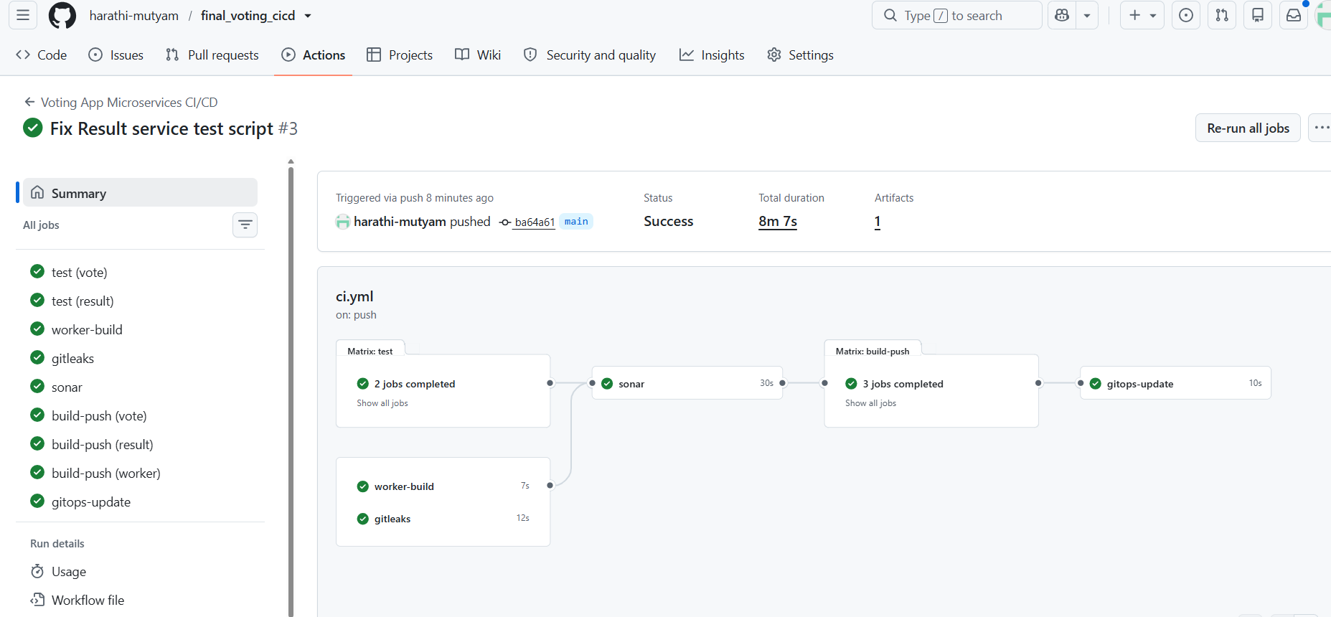
Step 8: Infrastructure creation

Open server gitbash Terminal
aws configure
provide access keys , secret keys , region: eu-north-1, output: json
cd ~
git clone https://github.com/harathi-mutyam/final_voting_cicd.git
cd ~/final_voting_cicd
cd terraform
terraform init
terraform fmt

terraform validate
Edit terraform.tfvars
cd ~/final_voting_cicd/terraform
vim terraform.tfvars
Update:
aws_region = "eu-north-1"
cluster_name = "voting-cluster"
kubernetes_version = "1.34"
node_instance_type , node_desired_size, node_min_size, node_max_size according to your requirement
Push changes from EC2 to Github repository
cd ~/final_voting_cicd
git status
git pull origin main
git config --global user.email ehmutyam@gmail.com
git config --global user.name harathi-mutyam
git add -f terraform/terraform.tfvars
git commit -m "Update EKS node group instance type and scaling configuration"
git push origin main
git status

admin_cidr = "16.171.144.221/32" #Replace with your public ip of server ec2 instance

change AWS region, Kubernetes version and admin_cidr settings according to your setup

Initialize Terraform:
cd terraform
terraform init
terraform validate
Expected:Success! The configuration is valid.
Check existing clusters:
aws eks list-clusters --region eu-north-1
output must be empty
Create Terraform Plan
terraform plan -out=tfplan
Review:
terraform show tfplan
Verify the AWS resources Terraform intends to create.

Verify Kubernetes Version Availability
aws eks describe-cluster-versions \
--region eu-north-1 \
--query 'clusterVersions[].{Version:clusterVersion,Status:status}' \
--output table
Verify that Kubernetes version 1.34 is supported before applying Terraform.
Check AWS EC2 vCPU Quota
aws service-quotas get-service-quota \
--service-code ec2 \
--quota-code L-1216C47A \
--region eu-north-1 \
--query 'Quota.Value'
This checks the standard On-Demand EC2 vCPU quota.

terraform apply tfplan
aws eks update-kubeconfig \
--region eu-north-1 \
--name voting-cluster

kubectl config current-context

Verify Worker Nodes Ready or not
kubectl get nodes -o wide
kubectl get pods -A
Verify EKS Node Group ACTIVE or not
aws eks describe-nodegroup \
--cluster-name voting-cluster \
--nodegroup-name voting-node-group \
--region eu-north-1 \
--query 'nodegroup.{Status:status,Scaling:scalingConfig,Health:health.issues}' \
--output json
Verify EKS Add-ons
aws eks list-addons \
--cluster-name voting-cluster \
--region eu-north-1
Check Whether the Voting App Is Already Deployed
Before installing Argo CD, verify the current Kubernetes environment.
Run:
kubectl get namespaces
kubectl get pods -A
kubectl get deployments -A
kubectl get svc -A
Actual observation before Argo CD installation:
Only the default Kubernetes namespaces existed:
Default

Step 9: Install Argo CD in voting server gitbash terminal

cd ~/final_voting_cicd
kubectl create namespace argocd \
--dry-run=client -o yaml | kubectl apply -f –

kubectl get namespaces
Download the Argo CD installation manifest
curl -fL \
https://raw.githubusercontent.com/argoproj/argo-cd/v3.5.6/manifests/install.yaml \
-o /tmp/argocd-install.yaml
Verify Argo CD's Kubernetes resources.
ls -lh /tmp/argocd-install.yaml
Install the required CRDs first . Download the version-matched ApplicationSet CRD:
curl -fL \
https://raw.githubusercontent.com/argoproj/argo-cd/v3.5.6/manifests/crds/applicationset-crd.yaml \
-o /tmp/applicationset-crd.yaml
# Install the ApplicationSet CRD:
kubectl apply --server-side \
-f /tmp/applicationset-crd.yaml
#Wait for Kubernetes to register it:
kubectl wait \
--for=condition=Established \
crd/applicationsets.argoproj.io \
--timeout=120s
The ApplicationSet Controller cannot operate without its CRD. Installing it before the controller starts prevents the missing-ApplicationSet error encountered during our original installation.
Install Argo CD
kubectl apply --server-side \
-n argocd \
-f /tmp/argocd-install.yaml

kubectl rollout status \
deployment/argocd-server \
-n argocd \
--timeout=300s

kubectl get crds | grep argoproj.io
Expected CRD names: applications.argoproj.io ,applicationsets.argoproj.io ,appprojects.argoproj.io
If a CRD is missing, investigate before deploying applications.
kubectl get pods -n argocd
kubectl get deployments,statefulsets -n argocd

Check resource allocation
kubectl describe nodes | grep -A 8 "Allocated resources:"
kubectl get pods -n argocd

For trouble shootingCheck logs
kubectl logs -n argocd \
deployment/argocd-applicationset-controller \
--tail=30
Get initial admin password for ArgoCD
kubectl -n argocd get secret argocd-initial-admin-secret \
-o jsonpath="{.data.password}" | base64 -d
echo
Copy it and save it
Access Argo CD Using Port Forwarding
Open one more new gitbash terminal
Connect to the voting-server EC2 instance using its public IP address through ssh command
sudo hostnamectl set-hostname argocd-port-forward
exec bash
For demo purpose give address as 0.0.0.0
kubectl port-forward svc/argocd-server \
-n argocd \
8080:443 \
--address=0.0.0.0
Forwarding from 0.0.0.0:8080 -> 8080
Open argocd dashboard in browser
http://your_server_ec2_publicip:8080

In Real time:
kubectl port-forward svc/argocd-server \
-n argocd \
8080:443 \
--address=127.0.0.1
Open one more new gitbash terminal
ssh -i ~/Downloads/voting_key.pem \
-L 8080:127.0.0.1:8080 \
ubuntu@YOUR_server_EC2_PUBLIC_IP
Open the Argo CD dashboard in Browser
https://localhost:8080
Provide login details as
Username : admin
password:Saved password from secret
Step 11: Create voting namespace and Create PostgreSQL Secret
kubectl create namespace voting \
--dry-run=client -o yaml | kubectl apply -f -
kubectl get namespace voting
grep -R -n -A 5 'secretKeyRef:' k8s/
If postgres-auth does not already exist, create it:

read -rsp "Enter PostgreSQL password: " DB_PASSWORD
echo

kubectl create secret generic postgres-auth \
-n voting \
--from-literal=password="$DB_PASSWORD"

unset DB_PASSWORD
Verify:
kubectl get secret postgres-auth -n voting

STEP 12 — Install Gateway API CRDs
open server gitbash terminal with hostname voting-server
cd final_voting_cicd
Gateway API extends Kubernetes with resources such as GatewayClass, Gateway and HTTPRoute.
Install the standard Gateway API CRDs required by NGINX Gateway Fabric v2.8.0:
kubectl kustomize \
'https://github.com/nginx/nginx-gateway-fabric/config/crd/gateway-api/standard?ref=v2.8.0' \
| kubectl apply -f -
Verify:
kubectl get crds | grep gateway.networking.k8s.io
Wait for the Gateway CRD:
kubectl wait \
--for=condition=Established \
crd/gateways.gateway.networking.k8s.io \
--timeout=120s
Wait for HTTPRoute:
kubectl wait \
--for=condition=Established \
crd/httproutes.gateway.networking.k8s.io \
--timeout=120s
Do not proceed if these CRDs are missing.
Install NGINX Gateway Fabric in voting-server EC2 terminal
NGINX Gateway Fabric is the Gateway API controller responsible for routing external HTTP traffic to the Kubernetes Services.
Install using Helm
helm install ngf \
oci://ghcr.io/nginx/charts/nginx-gateway-fabric \
--version 2.8.0 \
--create-namespace \
-n nginx-gateway \
--wait \
--timeout 10m
Verify Helm release
helm list -n nginx-gateway
Expected release name: ngf
Verify Pods
kubectl get pods -n nginx-gateway
Wait for controller availability:
kubectl rollout status \
deployment/ngf-nginx-gateway-fabric \
-n nginx-gateway \
--timeout=300s

kubectl get gatewayclass # Verify GatewayClass
Expected GatewayClass: nginx
Its acceptance status should be True.
The NGINX Gateway controller itself does not require a public LoadBalancer Service. The Gateway's data plane will receive the public LoadBalancer when the Gateway resource is reconciled.

Step 13: Deploy Voting App using Argo CD
cd ~/final_voting_cicd
kubectl apply -f argocd/voting-app.yaml -n argocd
Verify Application
open Argocd in browser and refresh it.
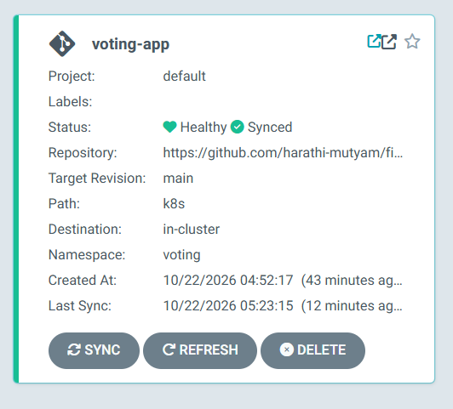
In server gitbash terminal
kubectl get application voting-app -n argocd

kubectl get pods -n voting

kubectl get secret postgres-auth -n voting

kubectl get pvc -n voting

kubectl get gateway -n voting
kubectl get httproute -n voting

kubectl get storageclass

kubectl get pods -n kube-system | grep ebs-csi

kubectl get gateway,httproute -n voting
NAME CLASS ADDRESS PROGRAMMED AGE
voting-gateway nginx a395a070b451c45c7bfd21f928418c1d-1245277792.eu-north-1.elb.amazonaws.com True 19m

copy the DNS address
Step 14:Test Voting App through Gateway in browser
Vote application
http://paste dns address
ex: http:// a395a070b451c45c7bfd21f928418c1d-1245277792.eu-north-1.elb.amazonaws.com
Result application: open one more tab
http://paste dns address/result
example:
http:// a395a070b451c45c7bfd21f928418c1d-1245277792.eu-north-1.elb.amazonaws.com/result

Troubleshooting — Voting App Not Loading in Browser
If the Vote or Result application does not load in the browser, verify the Kubernetes Gateway and HTTPRoute configurations.
kubectl describe gateway voting-gateway -n voting

kubectl describe httproute vote-route -n voting

kubectl describe httproute result-route -n voting
Check that both routes report Accepted=True and ResolvedRefs=True.
kubectl logs -n voting deployment/worker --tail=50

Optional for demo Purpose before start monitoring part run below commands
Verify resources before installing monitoring in voting-server EC2 gitbash terminal
cd ~/final_voting_cicd
kubectl get nodes -o wide
kubectl top nodes

kubectl top pods -A
If kubectl top reports Metrics API not available, check whether Metrics Server is installed:
kubectl get deployment metrics-server -n kube-system
Also check available resources on your two worker nodes:
kubectl describe nodes | grep -A 8 "Allocated resources:"
current configuration uses two c7i-flex.large nodes. Since Prometheus, Grafana, Alertmanager and Loki require additional resources, we should use a lightweight configuration for this demo.
Monitoring Part
Step 15: Install Prometheus, Grafana and Alertmanager
Here we use official community kube-prometheus-stack Helm chart, which includes Prometheus, Grafana, Alertmanager, Prometheus Operator, kube-state-metrics and Node Exporter
kubectl create namespace monitoring \
--dry-run=client -o yaml | kubectl apply -f -
Add Prometheus Helm repository
helm repo add prometheus-community \
https://prometheus-community.github.io/helm-charts

helm repo update
# Verify that the chart is available:
helm search repo prometheus-community/kube-prometheus-stack

cat monitoring/prometheus-values.yaml
if file exits continue below procedure
helm template monitoring \
prometheus-community/kube-prometheus-stack \
-n monitoring \
-f monitoring/prometheus-values.yaml \
> /tmp/voting-monitoring-rendered.yaml
If the command completes without errors, the chart has rendered successfully
Install the monitoring stack
helm upgrade --install monitoring \
prometheus-community/kube-prometheus-stack \
-n monitoring \
-f monitoring/prometheus-values.yaml \
--wait \
--timeout 15m
Verify:
kubectl get pods -n monitoring
kubectl get svc -n monitoring
helm list -n monitoring
kubectl top nodes
error: Metrics API not available

Check whether Metrics Server is installed
kubectl get deployment metrics-server -n kube-system
Check the Metrics API:
kubectl get apiservice v1beta1.metrics.k8s.io
Check EKS Metrics Server add-on
aws eks describe-addon \
--cluster-name voting-cluster \
--addon-name metrics-server \
--region eu-north-1
Output: ResourceNotFoundException
Install Metrics Server
aws eks create-addon --cluster-name voting-cluster \
--addon-name metrics-server --region eu-north-1

aws eks wait addon-active --cluster-name voting-cluster \
--addon-name metrics-server --region eu-north-1
Verify Metrics Server
kubectl get deployment metrics-server -n kube-system
Check the API:
kubectl get apiservice v1beta1.metrics.k8s.io
Expected API status:
v1beta1.metrics.k8s.io kube-system/metrics-server True
kubectl top nodes
kubectl top pods -n voting
kubectl top pods -n monitoring

Step 16: Access Grafana
Open one new gitbash terminal : login using server ec2 publicip
sudo hostnamectl set-hostname grafana-port-forward
exec bash
kubectl port-forward \
-n monitoring \
svc/monitoring-grafana \
3000:80 --address=0.0.0.0
Forwarding from 0.0.0.0:3000 -> 3000
Open browser:
http://server_ec2_public_ip:3000
username : admin
here we required password for grafana
open server gitbashterminal Retrieve the Grafana admin password
kubectl get secret monitoring-grafana \
-n monitoring \
-o jsonpath='{.data.admin-password}' | base64 -d
Echo
Copy the password paste it in browser
After login into Grafana Verify Prometheus data source
Open Connections → Data sourcesSelect the existing Prometheus data sourceVerify that the URL points to your monitoring Prometheus service Click Save & test. Or Test click Test again
Expected result: The Prometheus data source is working.
Test metrics
Open Explore, select Prometheus select code(on Right side) type: up run symbol (refresh Symbol on Top with blue colour):
A value of 1 indicates that Prometheus successfully scraped that target.
Next, check your Voting App Pods:
kube_pod_status_phase{namespace="voting",phase="Running"}
For Pods currently in the Running phase, the corresponding series should have a value of 1.
Verify Kubernetes Dashboards
In Grafana browser Navigate to Dashboards → Browse.
Look for the dashboard:
Kubernetes / Compute Resources / Namespace (Pods)
Open it and select:
- Data source: Prometheus
- Namespace: voting
You should be able to inspect CPU and memory usage for the Voting App Pods.

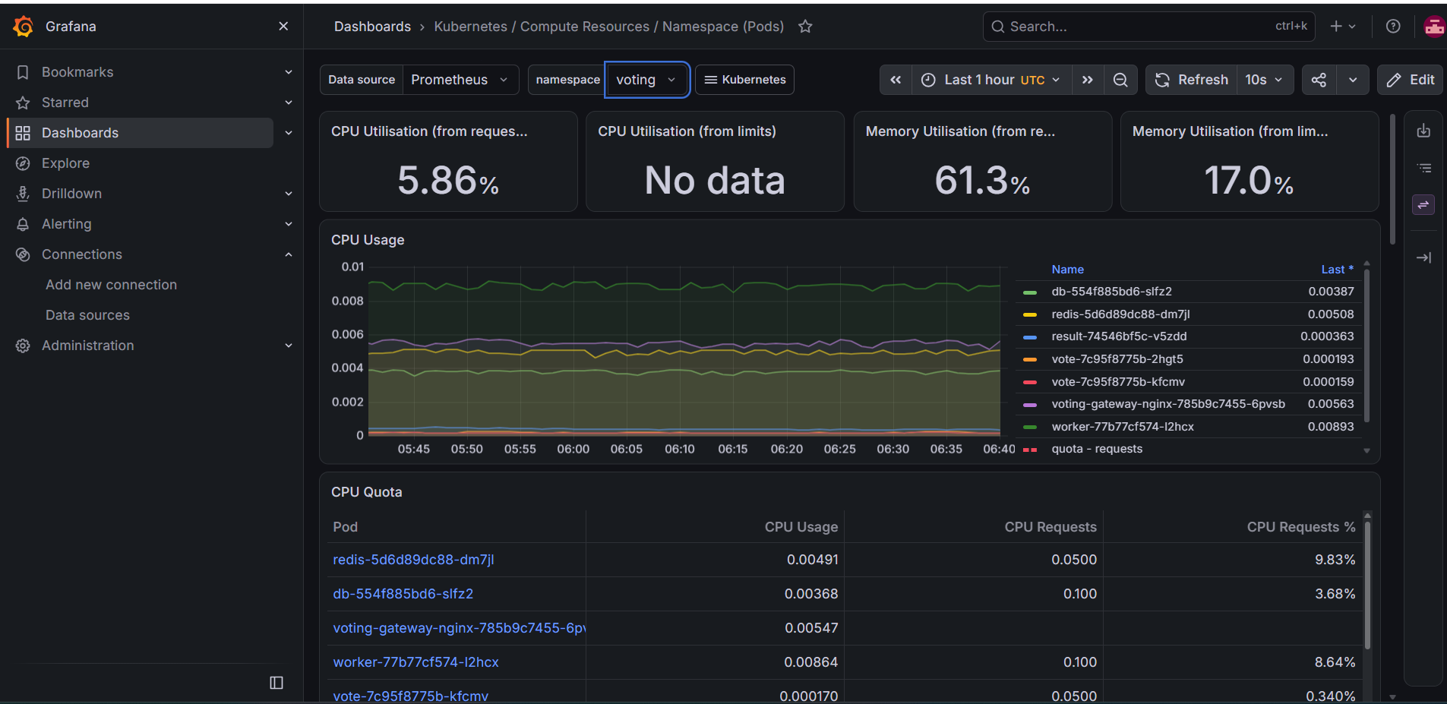
STEP 17 — Verify Alertmanager
open voting-server EC2 gitbash terminal
kubectl get alertmanager -n monitoring
kubectl get prometheusrules -n monitoring
kubectl get pods -n monitoring # Verify that the Alertmanager Pod is still running
open new gitbash terminal login using server ec2 gitbash terminal
ssh -i ~/Downloads/voting_key.pem ubuntu@<server_ec2_PUBLIC_IP>
sudo hostnamectl set-hostname alertmanager-port-forward
exec bash
kubectl port-forward -n monitoring \
svc/monitoring-kube-prometheus-alertmanager \
9093:9093 --address=0.0.0.0
Forwarding from 0.0.0.0:9093 -> 9093
Open browser access alertmanager with this ip
http://server_public_ec2_ip:9093

Use an SSH tunnel for port 9093 if accessing it from your Windows computer, then open http://localhost:9093. Or http://server_public_ec2_ip:9093
Check the Alerts and Silences sections. Installing Alertmanager does not automatically configure email notifications.
STEP 18 — Check Cluster Capacity Before Loki
Open server gitbash terminal
kubectl top nodes
kubectl top pods -n monitoring
kubectl top pods -n voting
Also check available memory and CPU allocations:
kubectl describe nodes | grep -A 8 "Allocated resources:"
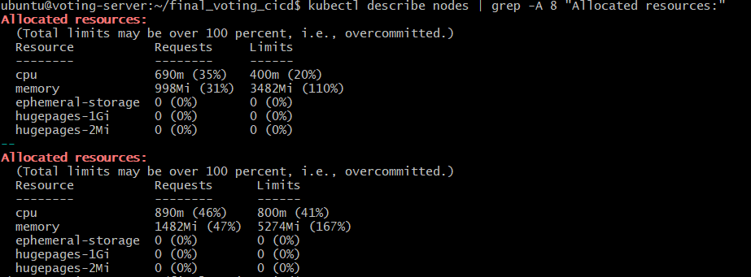
Notes for reference
Metric | Node 1 | Node 2
CPU utilization | 5% | 6%
Memory utilization | 50% | 78%
CPU requests | 35% | 46%
Memory requests | 31% | 47%
Memory limits | 110% | 167%
Interpretation: CPU capacity is sufficient at the moment. Memory is the main constraint, particularly on Node 2.
Memory limits above 100% indicate overcommitment, not necessarily a problem by themselves. However, if multiple containers approach their limits simultaneously, you could experience memory pressure or OOMKilled containers.

2. Monitoring Pod analysis
Your monitoring stack is using approximately:
Component | Memory
Grafana | 444 MiB
Prometheus | 348 MiB
Alertmanager | 23 MiB
Prometheus Operator | 21 MiB
kube-state-metrics | 18 MiB
Node Exporter (both Pods) | 22 MiB
Total | 876 MiB
Grafana is using 444 MiB against its configured 512 MiB limit, leaving only about 68 MiB of headroom. This is worth monitoring because dashboards and queries can increase memory usage.
Prometheus is using 348 MiB against its 1 GiB limit, which is currently acceptable.

3. Recommendation before Loki installation
I do not recommend installing Loki immediately with the default Helm chart values.
For your two-node c7i-flex.large cluster, use a deliberately lightweight Loki configuration. Even then, you should first inspect available allocatable resources and verify whether Grafana is approaching its memory limit.

Check resource pressure before installing loki because here I am using c7i-flex.Lrage for nodes
Open server gitbash terminal
kubectl get nodes -o wide
kubectl describe nodes | grep -E \
'Name:|MemoryPressure|DiskPressure|PIDPressure'
kubectl get nodes \
-o custom-columns=NAME:.metadata.name,ALLOCATABLE_MEMORY:.status.allocatable.memory,ALLOCATABLE_CPU:.status.allocatable.cpu

kubectl get pods -A \
-o jsonpath='{range .items[*]}{.metadata.namespace}{" / "}{.metadata.name}{" / "}{range .status.containerStatuses[*]}{.name}{": "}{.lastState.terminated.reason}{" "}{end}{"\n"}{end}' \
| grep OOMKilled
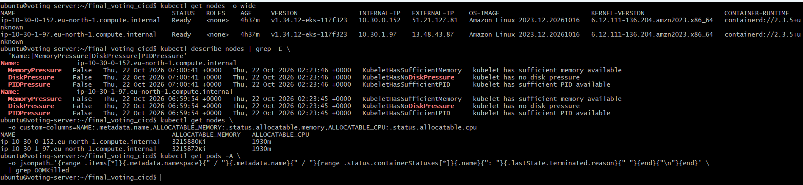
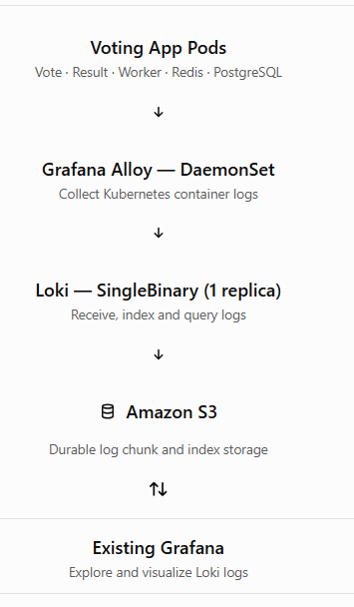
Here I am using an Amazon S3 bucket instead of filesystem storage for Loki
STEP 19 — Configure Amazon S3 Storage for Loki
Open server ec2 gitbahs terminal
cd ~/final_voting_cicd
export AWS_REGION=eu-north-1
export CLUSTER_NAME=voting-cluster
export ACCOUNT_ID=$(aws sts get-caller-identity --query Account --output text)
echo "AWS Account: $ACCOUNT_ID"
echo "Cluster: $CLUSTER_NAME"
echo "Region: $AWS_REGION"
Create two S3 buckets
Grafana recommends separate buckets for Loki chunks and ruler data. An admin bucket is not required for open-source Loki.
export LOKI_CHUNKS_BUCKET="voting-loki-chunks-${ACCOUNT_ID}-${AWS_REGION}"
export LOKI_RULER_BUCKET="voting-loki-ruler-${ACCOUNT_ID}-${AWS_REGION}"
Create the buckets:
aws s3api create-bucket \
--bucket "$LOKI_CHUNKS_BUCKET" \
--region "$AWS_REGION" \
--create-bucket-configuration LocationConstraint="$AWS_REGION"

aws s3api create-bucket \
--bucket "$LOKI_RULER_BUCKET" \
--region "$AWS_REGION" \
--create-bucket-configuration LocationConstraint="$AWS_REGION"
If either bucket already exists in your account, verify its region and reuse it rather than recreating it.
Block public access:
for BUCKET in "$LOKI_CHUNKS_BUCKET" "$LOKI_RULER_BUCKET"; do
aws s3api put-public-access-block \
--bucket "$BUCKET" \
--public-access-block-configuration \
BlockPublicAcls=true,IgnorePublicAcls=true,BlockPublicPolicy=true,RestrictPublicBuckets=true

aws s3api put-bucket-encryption \
--bucket "$BUCKET" \
--server-side-encryption-configuration \
'{"Rules":[{"ApplyServerSideEncryptionByDefault":{"SSEAlgorithm":"AES256"}}]}'
done
verify:
aws s3 ls | grep voting-loki
Create a dedicated IAM policy
Do not put AWS access keys inside loki-values.yaml. We will grant Loki access to only the two S3 buckets using an IAM role.
Create the IAM policy document:
cat > /tmp/voting-loki-s3-policy.json <<EOF
{
"Version": "2012-10-17",
"Statement": [
{
"Effect": "Allow",
"Action": ["s3:ListBucket", "s3:GetBucketLocation"],
"Resource": [
"arn:aws:s3:::${LOKI_CHUNKS_BUCKET}",
"arn:aws:s3:::${LOKI_RULER_BUCKET}"
]
},
{
"Effect": "Allow",
"Action": [
"s3:GetObject",
"s3:PutObject",
"s3:DeleteObject"
],
"Resource": [
"arn:aws:s3:::${LOKI_CHUNKS_BUCKET}/*",
"arn:aws:s3:::${LOKI_RULER_BUCKET}/*"
]
}
]
}
EOF
Create the IAM policy:
aws iam create-policy \
--policy-name VotingLokiS3Policy \
--policy-document file:///tmp/voting-loki-s3-policy.json
Configure IAM authentication for Loki
For EKS, IRSA allows a Kubernetes ServiceAccount to assume a dedicated IAM role through the cluster's OIDC identity provider. This avoids static credentials in Helm values
First check whether the OIDC provider is associated with your cluster
aws eks describe-cluster \
--name "$CLUSTER_NAME" \
--region "$AWS_REGION" \
--query 'cluster.identity.oidc.issuer' \
--output text

eksctl version
here we will get error eksctl not installed
Install eksctl and configure Loki IAM access
Open server gitbash terminal Install eksctl
ARCH=amd64
PLATFORM=Linux_$ARCH
curl -sLO \
"https://github.com/eksctl-io/eksctl/releases/latest/download/eksctl_${PLATFORM}.tar.gz"

tar -xzf eksctl_${PLATFORM}.tar.gz
sudo install -m 0755 eksctl /usr/local/bin/eksctl

rm -f eksctl "eksctl_${PLATFORM}.tar.gz"
eksctl version #we will get eksctl version number.
Create logging namespace
kubectl create namespace logging \
--dry-run=client -o yaml | kubectl apply -f -
Create the IAM ServiceAccount:
eksctl create iamserviceaccount \
--cluster "$CLUSTER_NAME" \
--region "$AWS_REGION" \
--namespace logging \
--name loki \
--role-name VotingLokiS3Role \
--attach-policy-arn "arn:aws:iam::${ACCOUNT_ID}:policy/VotingLokiS3Policy" \
--approve
If the OIDC provider has not been associated, associate it first:
eksctl utils associate-iam-oidc-provider \
--cluster "$CLUSTER_NAME" --region "$AWS_REGION" \
--approve

Then rerun the IAM ServiceAccount creation command.
Verify:
kubectl get serviceaccount loki -n logging -o yaml
You should see an annotation similar to:
eks.amazonaws.com/role-arn: arn:aws:iam::<ACCOUNT_ID>:role/VotingLokiS3Role
The Helm configuration will reuse this ServiceAccount rather than create a new one.
STEP 20 — Configure Loki Helm Values for S3
Add Grafana community Helm repository
The Loki chart is now maintained in the Grafana community Helm repository
helm repo add grafana-community \
https://grafana-community.github.io/helm-charts
helm repo update
helm search repo grafana-community/loki --versions | head
aws s3 ls
copy the bucket values .Replace the two bucket placeholders with your actual bucket names.so open
vim nano logging/loki-values.yaml
replace chunks bucket name , ruler bucket name in loki-values.yaml file and save it
Validate the Loki configuration
Because Helm chart options change between releases, validate the selected chart before installing.
helm show values grafana-community/loki \
> /tmp/loki-default-values.yaml
Render the deployment:
helm template loki grafana-community/loki \
--version 19.0.3 \
-n logging \
-f logging/loki-values.yaml \
> /tmp/voting-loki-rendered.yaml
If the command completes without errors, Helm successfully rendered the Kubernetes manifests. It does not yet prove Loki can access S3.
STEP 21 — Loki installation and readiness
kubectl top nodes
kubectl get pods -A
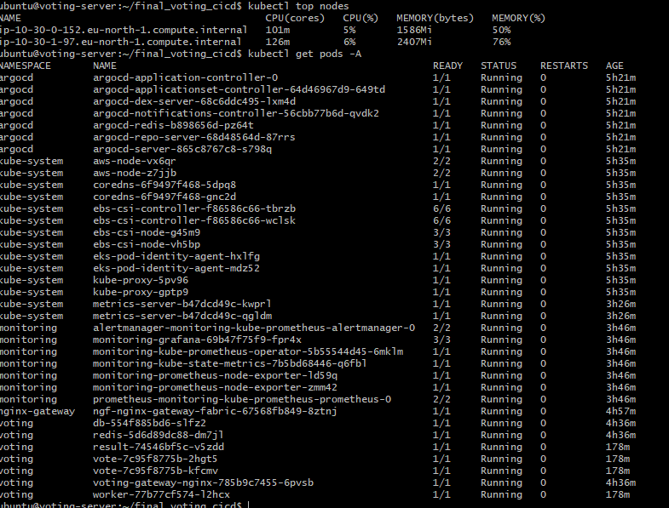
If sufficient capacity remains, install:
helm upgrade --install loki grafana-community/loki \
--version 19.0.3 -n logging \
-f logging/loki-values.yaml \
--wait --timeout 15m
Verify:
kubectl get pods -n logging
kubectl get pvc -n logging
kubectl get svc -n logging
helm list -n logging
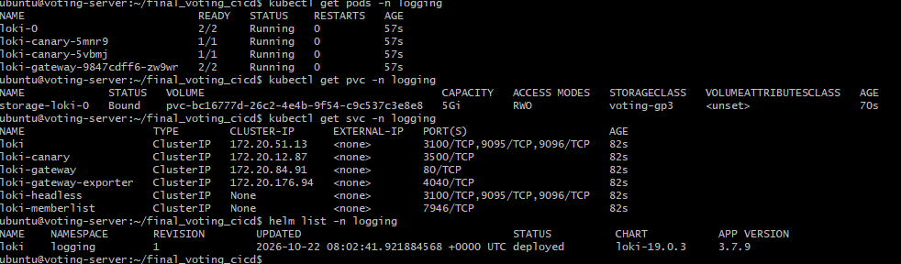
Open new gitbash terminal login with server ec2 publicip
sudo hostnamectl set-hostname loki-port-forward
exec bash
Check Loki's readiness endpoint using the service name shown by kubectl get svc:
kubectl port-forward -n logging \
svc/loki-gateway 3100:3100
Forwarding from 0.0.0.0:3100 -> 3100

Open oldvoting-server gitbash terminal:
ubuntu@voting-server:~/final_voting_cicd$
cd final_voting_cicd
curl http://localhost:3100/ready
A healthy Loki instance should return ready.
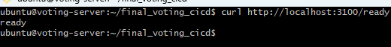
STEP 22 — Connect Loki to Existing Grafana
WHERE: Grafana browser
- Open Connections → Data sources.
- Select Add new data source.
- Choose Loki.
- Enter the internal Loki service URL, for example
http://loki-gateway.logging.svc.cluster.local/
- Click Save & test.
This configures Grafana to query Loki, but logs will not appear until Grafana Alloy is installed and configured to collect Kubernetes container logs.
Grafana Alloy will be the next installation step.

STEP 23 — Verify S3 Storage
Open server gitbash terminal
echo "$LOKI_CHUNKS_BUCKET"
echo "$LOKI_RULER_BUCKET"
After Alloy begins forwarding logs, check that Loki is writing objects into S3:
aws s3 ls "s3://${LOKI_CHUNKS_BUCKET}/" --recursive --summarize
You can also inspect the ruler bucket:
aws s3 ls "s3://${LOKI_RULER_BUCKET}/" --recursive
The ruler bucket may remain empty until you configure Loki recording or alerting rules.
Confirm log ingestion in Grafana
Open Grafana and navigate to:
Explore → Loki datasource select code
Run this LogQL query:
{namespace="voting"}
It returns nothing because alloy not yet installed
Open server gitbash terminal
kubectl get pods -n logging -o wide
kubectl get pods -A | grep -i alloy
helm list -A
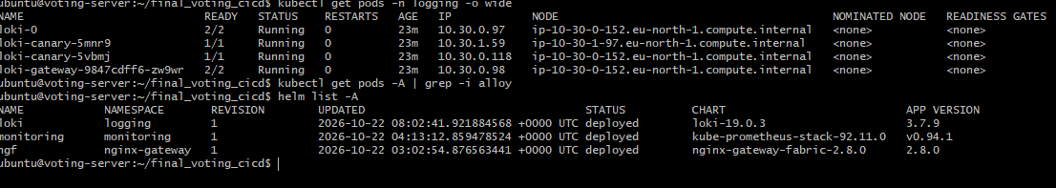
STEP 24 — check the Configuration of loki-values.yaml
After verifying the installation:
cd ~/final_voting_cicd
cat logging/loki-values.yaml
optional command if you change any thing in logging/loki-values.yaml
then only push it
git status
git add logging/loki-values.yaml
git commit -m "add: configure Loki S3 storage for voting app logs"
git push origin main
Step 25: Install Grafana Alloy
Before installation Run these commands
cd ~/final_voting_cicd
kubectl get daemonsets -A
kubectl get deployments -A | grep -i alloy
kubectl top nodes
# Add Grafana repository
helm repo add grafana \
https://grafana.github.io/helm-charts
helm repo update
# Check committed configuration
cat logging/alloy-values.yaml
# Render Helm manifests
helm template alloy grafana/alloy \
--version 1.14.1 \
-n logging \
-f logging/alloy-values.yaml \
> /tmp/voting-alloy-rendered.yaml
If the command finishes without errors, the Helm templates have rendered successfully.
# Verify DaemonSet
grep -A 3 'kind: DaemonSet' \
/tmp/voting-alloy-rendered.yaml

# Verify node-name environment variable
grep -A 6 'name: K8S_NODE_NAME' \
/tmp/voting-alloy-rendered.yaml

# Install Alloy
helm upgrade --install alloy grafana/alloy \
--version 1.14.1 \
-n logging \
-f logging/alloy-values.yaml \
--wait \
--timeout 10m
# Verify installation
kubectl get daemonsets -n logging
kubectl get pods -n logging
helm list -n logging
kubectl top pods -n logging
kubectl top nodes
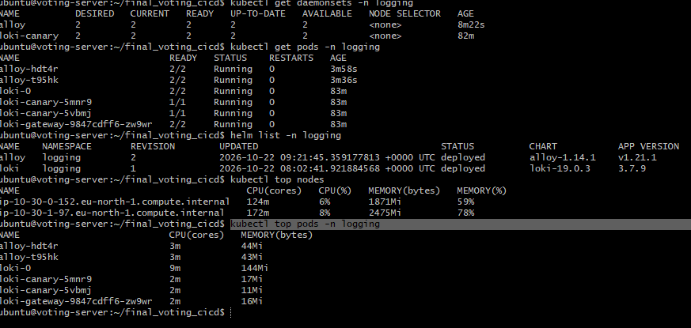
Total Alloy memory usage: 87 MiB across both worker nodes.
Optional command Check Alloy runtime logs
kubectl logs -n logging \
-l app.kubernetes.io/name=alloy \
-c alloy \
--tail=50 \
--max-log-requests=5
Check for errors such as permission denied, connection refused, failed to send batch, or configuration parsing failures.
kubectl get svc -n logging
Confirm that loki-gateway exists and exposes port 80.
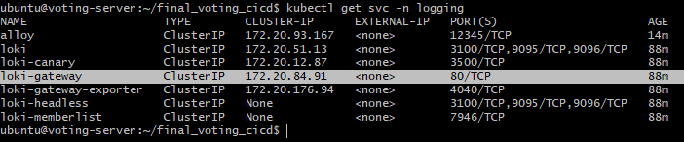
Step 26: Verify Grafana logs
Generate Voting App activity
Access your Voting App using its existing Gateway URL run the below command in server gitbash terminal
kubectl get gateway -n voting
copy the dns address check it in browser
vote: http://dnsaddress
result: http://dnsadress/result
and cast a few test votes. This generates application traffic, although actual log output depends on whether the application logs those requests.
Check logs in Grafana browser
Open GrafanaconnectionsDatasourcesAdd new data sourcesearch loki
Connection: URL: http://loki-gateway.logging.svc.cluster.local/
Provide or select this urlsave and test
Open Grafana → Explore, select your existing Loki data source,select code and set the time range to Last 30 minutes.
Run:type:{namespace="voting"} click on Run query
To check individual services:
{namespace="voting",container="vote"}
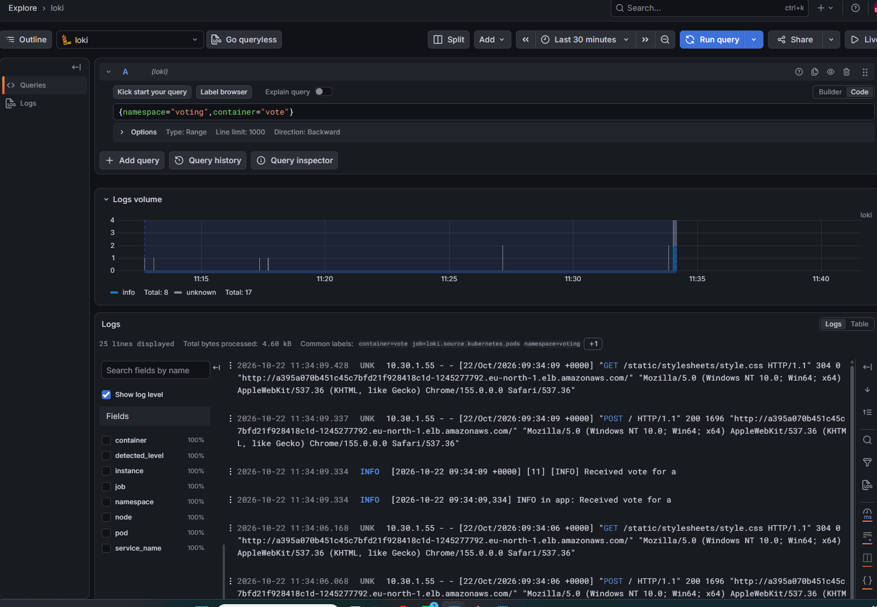
{namespace="voting",container="result"}
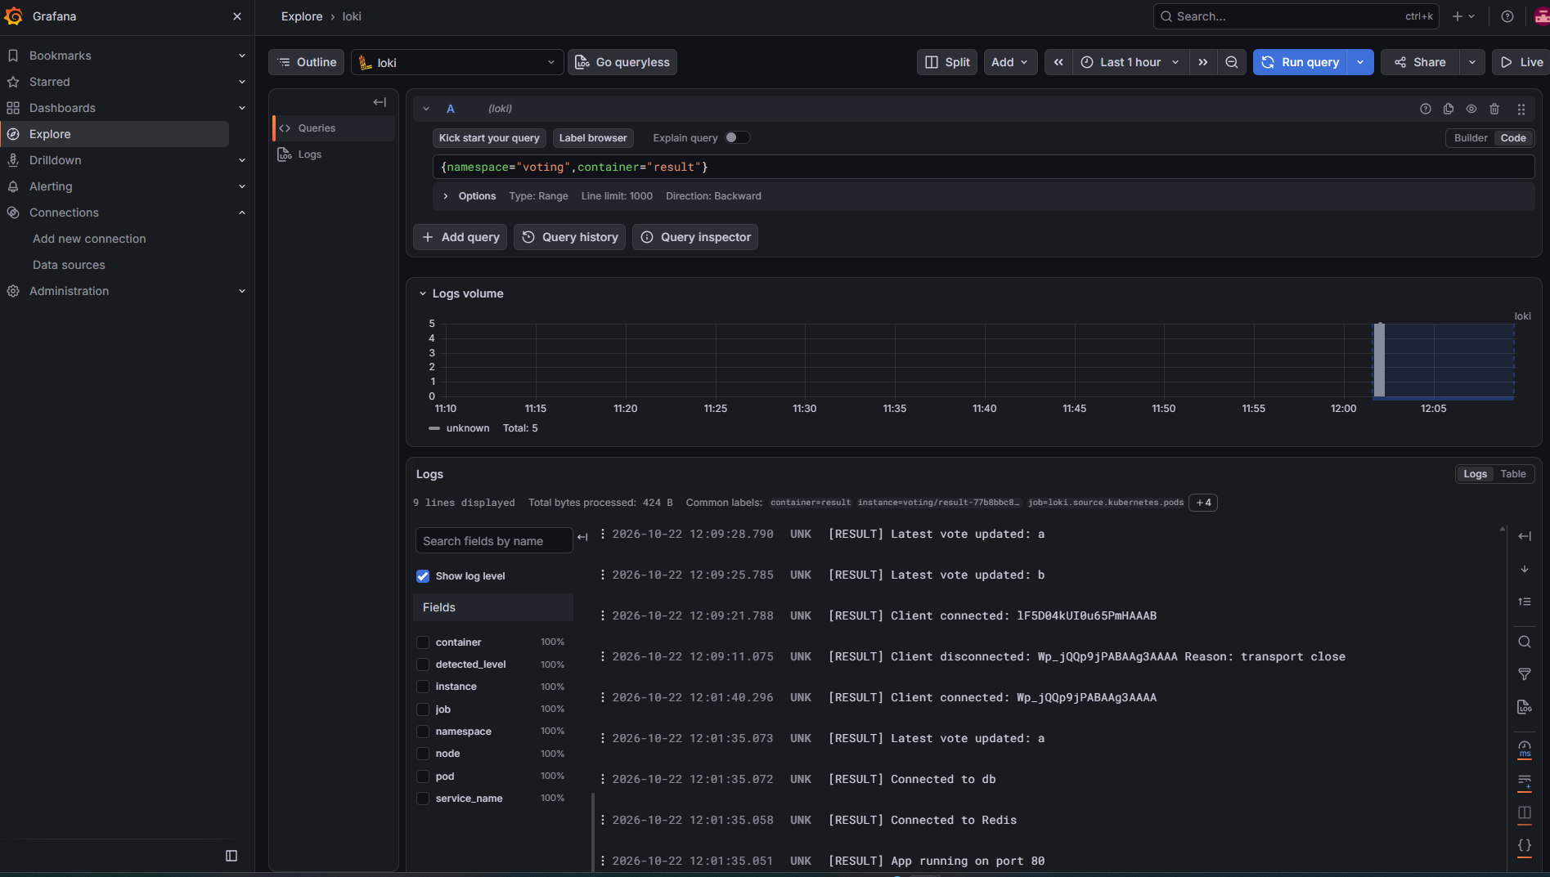
{namespace="voting",container="worker"}

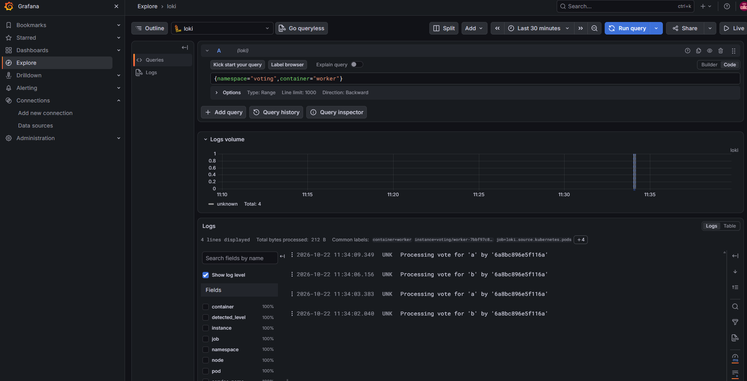

Click on Data Sourcesselect lokiBuild a Dashboard
Click on + symbol Tile: loki_application_logs
Description: Vote, Worker and Result application logs
Select Configure Visulisationselect All Visualizations(search logs)select Datasource : loki provide query as
{namespace="voting"}
Click on Run querysave Provide Title: Voting App - Centralized Logging Save it
Again Select Configure Visulisationselect All Visualizations(search logs)select Datasource : loki provide query as
{namespace="voting",container="result"}
Click on Run querysave Message : enter discrptionas result logssave

Repeat same procedure for Prometheus and alert manager also
Panel | Visualization | Unit | Query
Prometheus Targets UP | Stat | None | sum(up == 1)
EKS Worker Nodes Ready | Stat | None | sum(kube_node_status_condition{condition="Ready",status="true"} == 1)
Voting App Running Pods | Stat | None | sum(kube_pod_status_phase{namespace="voting",phase="Running"} == 1)
Voting App CPU Usage | Time series | CPU cores | CPU usage query
Voting App Memory Usage | Time series | Bytes (IEC) | Memory usage query
Voting App Pod Restarts | Bar gauge | None | Restart count query

STEP 26 — Verify Grafana Logs and S3 Persistence
export AWS_REGION=eu-north-1
export ACCOUNT_ID=$(aws sts get-caller-identity --query Account --output text)

export LOKI_CHUNKS_BUCKET="voting-loki-chunks-${ACCOUNT_ID}-${AWS_REGION}"
export LOKI_RULER_BUCKET="voting-loki-ruler-${ACCOUNT_ID}-${AWS_REGION}"
aws s3 ls | grep voting-loki
aws s3 ls "s3://${LOKI_CHUNKS_BUCKET}/" --recursive --summarize
aws s3 ls "s3://${LOKI_RULER_BUCKET}/" --recursive --summarize
Open aws console in browseropen s3 observe buckets created on chunks bucket logs saved
Voting App CI/CD — Complete AWS Deletion Commands
Project: final_voting_cicd Region: eu-north-1 Cluster: voting-cluster
Run Steps 1–10 on voting-server. Run Step 11 on voting-runner. Complete the remaining steps from AWS CloudShell.
Warning: These commands permanently delete project infrastructure and data. Verify that each resource belongs to the Voting App before deleting it.
STEP 1 — Verify AWS Account
aws sts get-caller-identity

aws eks list-clusters --region eu-north-1
STEP 2 — Delete Argo CD Application
kubectl -n argocd patch application voting-app \
--type merge \
-p '{"spec":{"syncPolicy":{"automated":null}}}'
kubectl -n argocd patch application voting-app \
--type merge \
-p '{"metadata":{"finalizers":["resources-finalizer.argocd.argoproj.io"]}}'
kubectl delete application voting-app \
-n argocd \
--wait=true \
--timeout=300s
kubectl get applications -n argocd
STEP 3 — Delete Voting Application Namespace
kubectl get pvc -n voting

kubectl delete namespace voting \
--wait=true \
--timeout=600s

kubectl get pv
Ensure application PVCs and PVs are removed before proceeding.
STEP 4 — Delete Loki and Alloy
helm list -n logging
helm uninstall alloy -n logging

helm uninstall loki -n logging
kubectl get pvc -n logging
If storage-loki-0 remains:
kubectl delete pvc storage-loki-0 \
-n logging \
--wait=false
Verify storage deletion:
kubectl get pvc -n logging

kubectl get pv
When Loki storage is removed:
kubectl delete namespace logging \
--wait=true \
--timeout=600s
STEP 5 — Delete Prometheus, Grafana and Alertmanager
helm list -n monitoring

helm uninstall monitoring -n monitoring
kubectl get pvc -n monitoring

kubectl get pv
If monitoring PVCs remain, verify their ownership and delete them:
kubectl delete pvc --all \
-n monitoring \
--wait=true \
--timeout=600s
kubectl delete namespace monitoring \
--wait=true \
--timeout=600s
STEP 6 — Delete NGINX Gateway Fabric
First remove any remaining Gateway API resources belonging to the Voting App and confirm that their load balancers are being released.
kubectl get gateway -A

kubectl get svc -A
Then uninstall the controller:
helm uninstall ngf -n nginx-gateway
kubectl delete namespace nginx-gateway \
--wait=true \
--timeout=600s
Verify AWS Load Balancers:
aws elbv2 describe-load-balancers \
--region eu-north-1 \
--query 'LoadBalancers[].LoadBalancerName' \
--output table
Do not proceed while a project load balancer remains.
STEP 7 — Delete Argo CD
kubectl get applications -n argocd
After confirming no applications remain:
kubectl delete namespace argocd \
--wait=true \
--timeout=600s
kubectl get pods -A
STEP 8 — Delete Loki CloudFormation Stack
STACK="eksctl-voting-cluster-addon-iamserviceaccount-logging-loki"
aws cloudformation update-termination-protection \
--stack-name "$STACK" \
--no-enable-termination-protection \
--region eu-north-1
aws cloudformation delete-stack \
--stack-name "$STACK" \
--region eu-north-1
aws cloudformation wait stack-delete-complete \
--stack-name "$STACK" \
--region eu-north-1
Skip this step if the stack was already deleted.
STEP 9 — Delete Remaining Loki IAM Policy
ACCOUNT_ID=$(aws sts get-caller-identity \
--query Account --output text)

POLICY_ARN="arn:aws:iam::${ACCOUNT_ID}:policy/VotingLokiS3Policy"
aws iam get-role \
--role-name VotingLokiS3Role

aws iam get-policy \
--policy-arn "$POLICY_ARN"
If the policy still exists:
aws iam list-entities-for-policy \
--policy-arn "$POLICY_ARN"
If no entities are attached and the policy belongs only to this project:
aws iam delete-policy \
--policy-arn "$POLICY_ARN"
If the role still exists, inspect and remove its remaining attachments and dependencies before deleting it.
STEP 10 — Terraform Destroy
cd ~/final_voting_cicd/terraform
terraform init

terraform state list
terraform plan -destroy -out=destroy.tfplan
Review the destruction plan:
terraform show destroy.tfplan
After verifying that only Voting App infrastructure will be deleted:
terraform apply destroy.tfplan
Verify:
terraform state list
aws eks list-clusters \
--region eu-north-1
Expected: No managed Terraform resources and no voting-cluster.
STEP 11 — Remove GitHub Actions Runner
WHERE: voting-runner EC2 terminal
cd ~/actions-runner
If the runner was installed as a service:
sudo ./svc.sh stop

sudo ./svc.sh uninstall
Remove GitHub registration:
./config.sh remove
Provide a GitHub runner removal token if requested.
STEP 12 — Delete Loki S3 Buckets
WHERE: AWS CloudShell
ACCOUNT_ID=$(aws sts get-caller-identity \
--query Account --output text)

CHUNKS_BUCKET="voting-loki-chunks-${ACCOUNT_ID}-eu-north-1"

RULER_BUCKET="voting-loki-ruler-${ACCOUNT_ID}-eu-north-1"
Verify bucket names:
aws s3api list-buckets \
--query 'Buckets[].Name' \
--output table
After confirming both buckets belong to this project and their logs are no longer required, delete them:
aws s3 rb "s3://${CHUNKS_BUCKET}" --force

aws s3 rb "s3://${RULER_BUCKET}" --force
These commands work for ordinary unversioned buckets. Versioned buckets require removal of all object versions and delete markers first.
STEP 13 — Terminate EC2 Instances
WHERE: AWS CloudShell
Identify the project instances:
aws ec2 describe-instances \
--region eu-north-1 \
--filters "Name=tag:Name,Values=voting-runner,voting-server" \
--query 'Reservations[].Instances[].{ID:InstanceId,Name:Tags[?Key==`Name`]|[0].Value,State:State.Name}' \
--output table
After confirming the exact instance IDs, terminate them:
aws ec2 terminate-instances \
--region eu-north-1 \
--instance-ids <VOTING_RUNNER_INSTANCE_ID> <VOTING_SERVER_INSTANCE_ID>
Replace the placeholders with verified instance IDs.
STEP 14 — Check Remaining AWS Resources
EKS:
aws eks list-clusters \
--region eu-north-1
EC2:
aws ec2 describe-instances \
--region eu-north-1 \
--filters "Name=instance-state-name,Values=pending,running,stopped,stopping" \
--query 'Reservations[].Instances[].InstanceId' \
--output table
EBS volumes:
aws ec2 describe-volumes \
--region eu-north-1 \
--query 'Volumes[].{ID:VolumeId,State:State,Size:Size}' \
--output table
Load Balancers:
aws elbv2 describe-load-balancers \
--region eu-north-1 \
--query 'LoadBalancers[].LoadBalancerName' \
--output table
NAT Gateways:
aws ec2 describe-nat-gateways \
--region eu-north-1 \
--query 'NatGateways[].{ID:NatGatewayId,State:State}' \
--output table
Elastic IPs:
aws ec2 describe-addresses \
--region eu-north-1 \
--query 'Addresses[].{IP:PublicIp,AllocationId:AllocationId}' \
--output table
VPCs:
aws ec2 describe-vpcs \
--region eu-north-1 \
--query 'Vpcs[].{ID:VpcId,CIDR:CidrBlock}' \
--output table
Security Groups:
aws ec2 describe-security-groups \
--region eu-north-1 \
--query 'SecurityGroups[].{ID:GroupId,Name:GroupName}' \
--output table
Review any remaining resources and delete only those verified as belonging to the Voting App. In particular, check for leftover EBS volumes, Elastic IPs and the project EC2 security group.
STEP 15 — Final Verification
aws eks list-clusters --region eu-north-1

aws s3api list-buckets \
--query 'Buckets[?contains(Name, `voting-loki`)].Name' \
--output table

aws cloudformation list-stacks \
--region eu-north-1 \
--stack-status-filter CREATE_COMPLETE UPDATE_COMPLETE \
--query 'StackSummaries[?contains(StackName, `voting-cluster`)].StackName' \
--output table
Deletion is complete when all Voting App resources have been removed and verified.
Your GitHub repository final_voting_cicd remains preserved for future deployments.

